How to Submit Entertainment Expense Reimbursement

- Log in to Concur by going to travel.ucla.edu and selecting “The New Express”

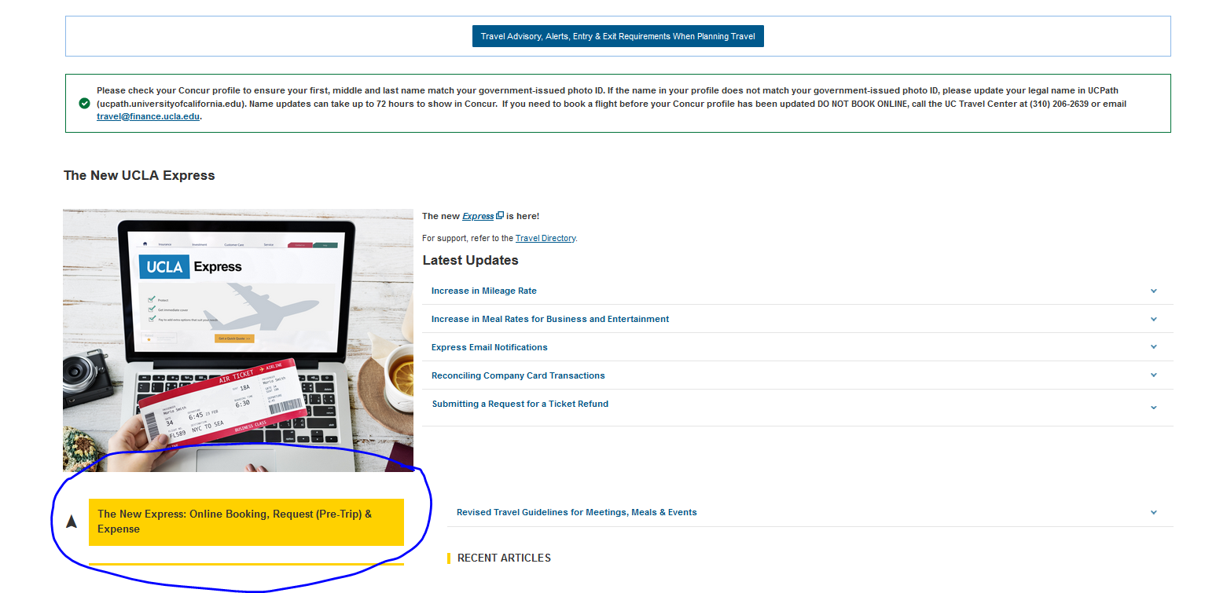

- Sign on with your UCLA Single Sing on

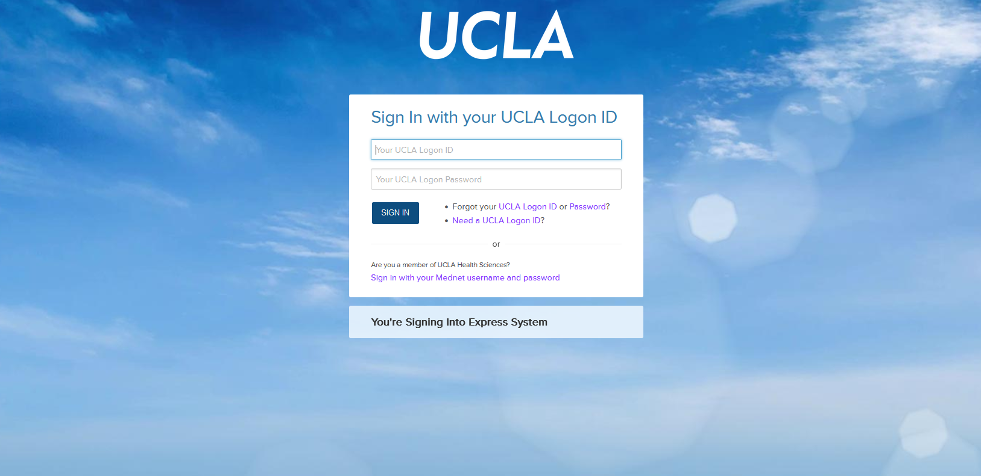

- At the top of the landing page, select “Expense

- Select “Create New Report”

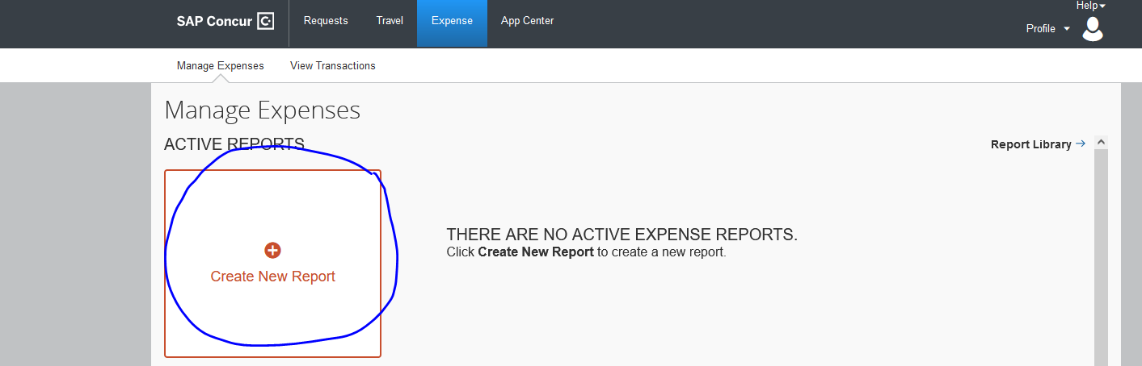

- Enter in the expense details, then press “Next” at the bottom of the right screen:

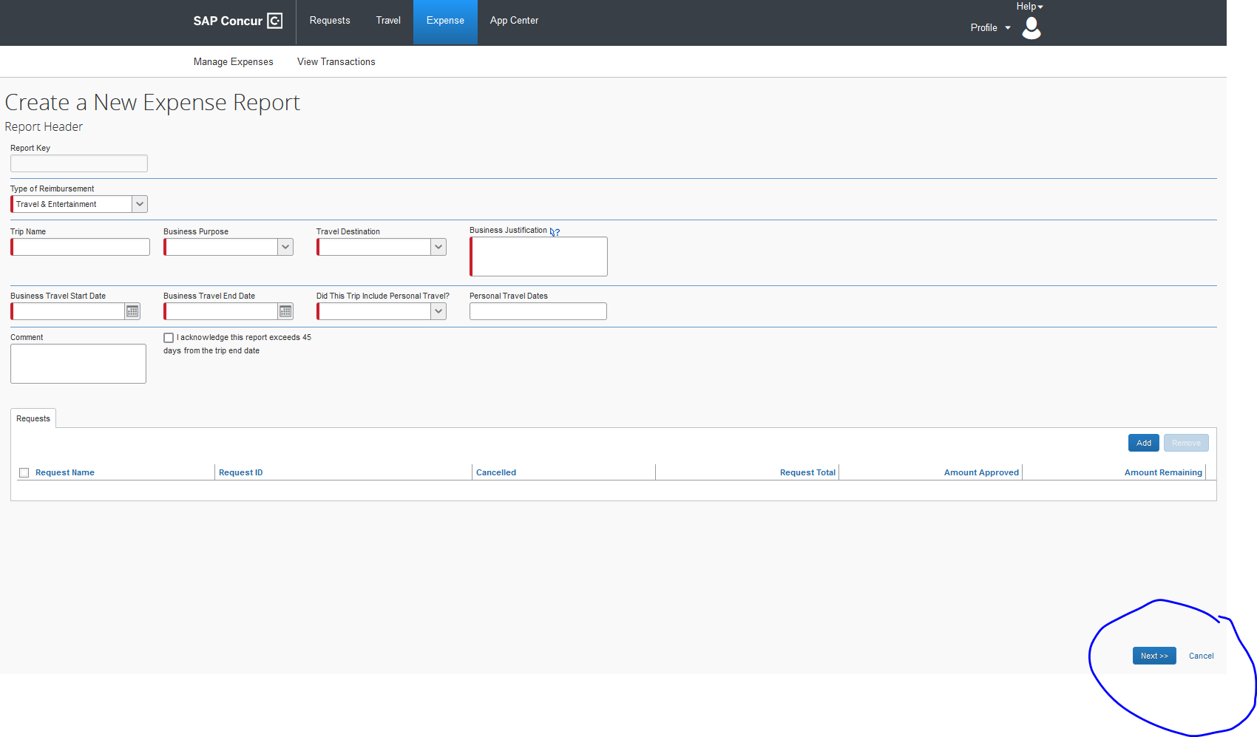

- Select the Expense Type (e.g., “Business Meals – Lunch”) and enter in the details
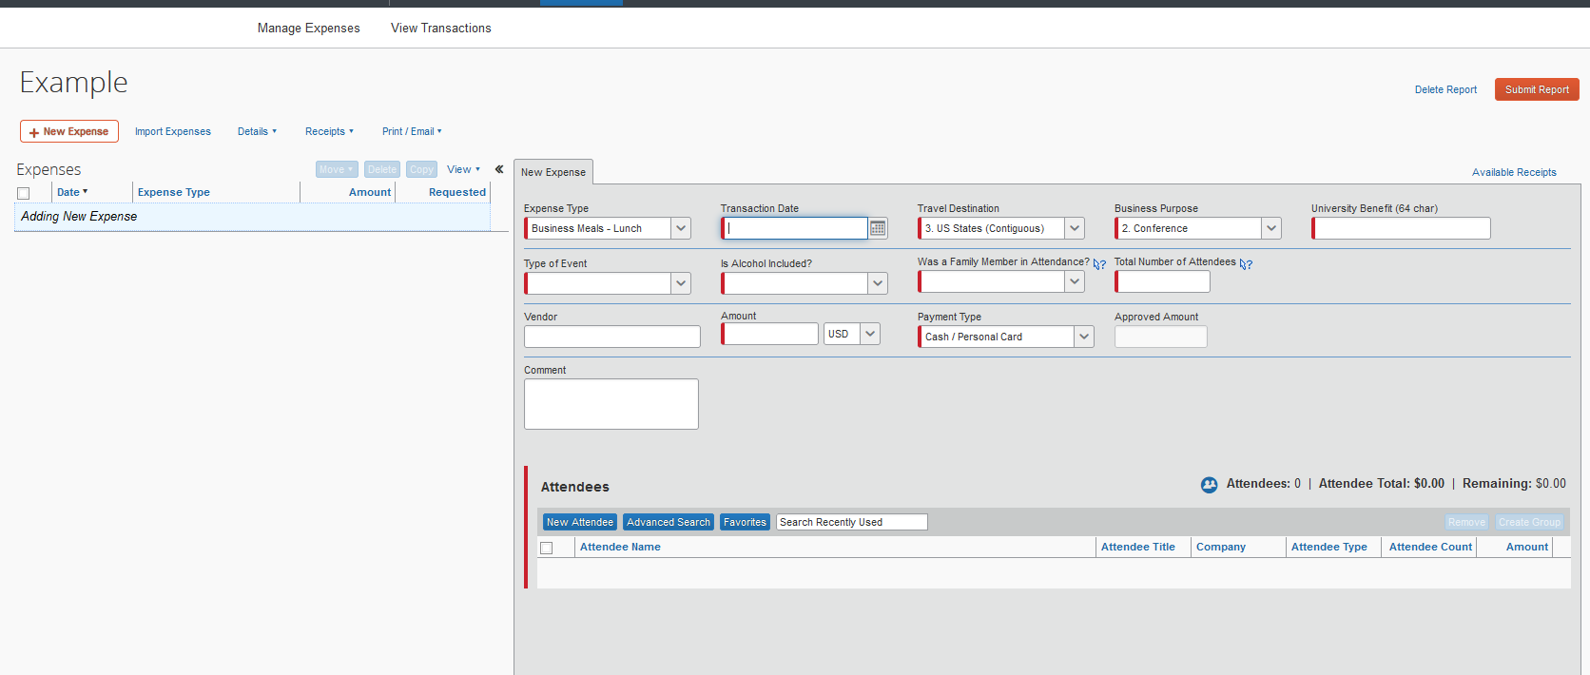

- Select “New Attendee” and provide new attendee information and then “Save”

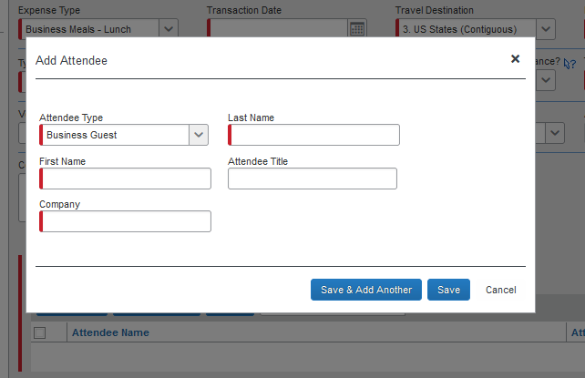

- Select “Allocate” and provide FAU information (Please make sure to choose Mark Lucas as the appropriate approver). If you are unsure of your FAU, please ask your fund manager.

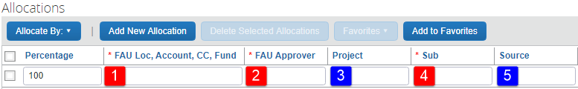

- Select “Attach Receipt” and include a pdf image of the receipt. Please make sure receipt is itemized and include proof of payment.

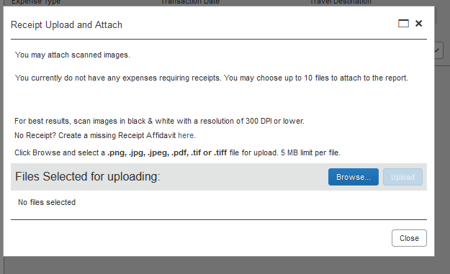

- Select “Save,” and when ready, “Submit Report”

