How to Submit Travel Expense Reimbursement

- Log in to Concur by going to travel.ucla.edu and selecting “The New Express”

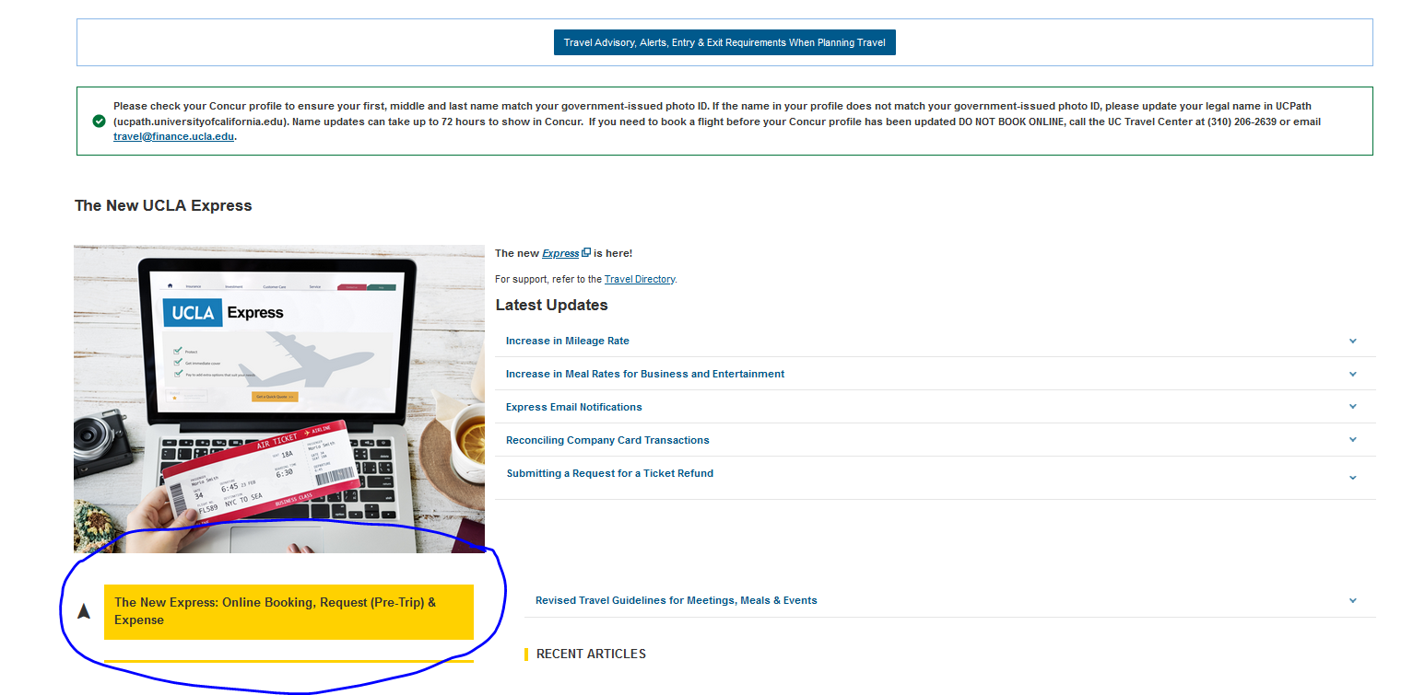

- Sign on with your UCLA Single Sing on

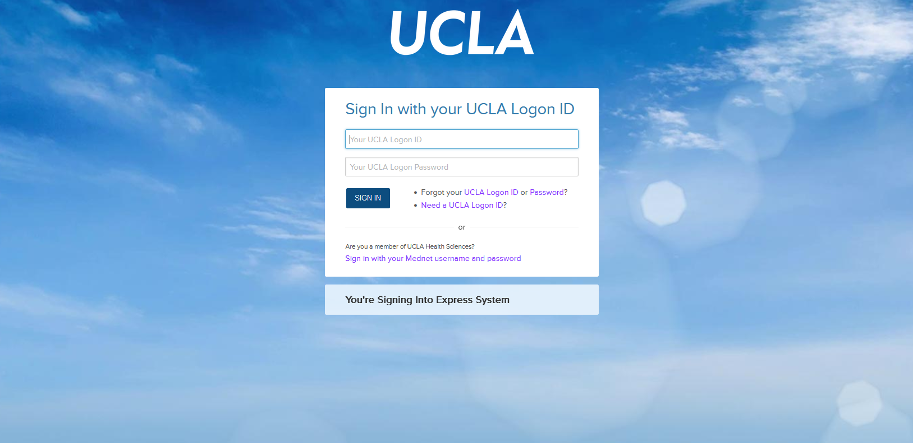

- From the home page, click Requests.
- Under Manage Requests, to the far right on the Request line, click the link for Expense
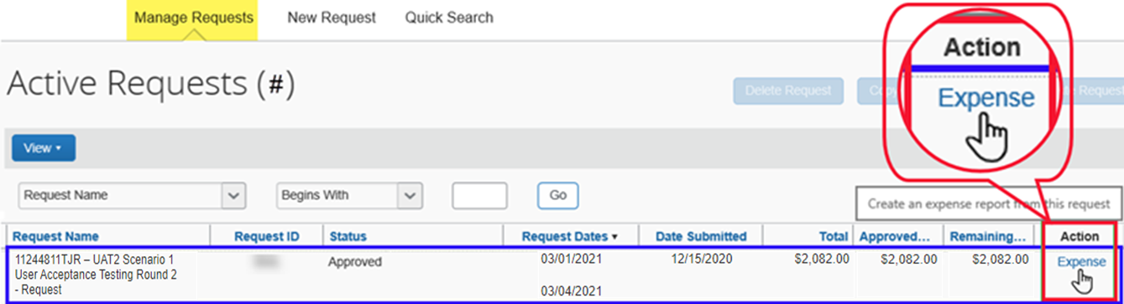

- In the Report Header, click the Type of Reimbursement drop down to select the proper Report Type of Travel & Entertainment
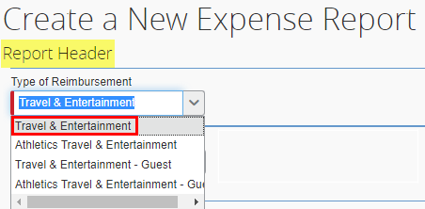

- Most of the information entered on the Request will come over and automatically populate the Expense Report Header. However, you may need to:
  - Update the Trip Name
  - Re-enter the Business Justification
- Towards the bottom of the screen, you will see a box that says Requests. Visually confirm the proper request is listed (if a request is listed, it means it is already attached to the report, so you do not need to click in the box or click the Add button)
- Click Next at the lower right part of the screen.
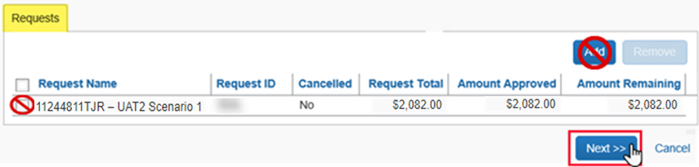

- A pop-up will appear asking “Will foreign meals or lodging be claimed?”, click No
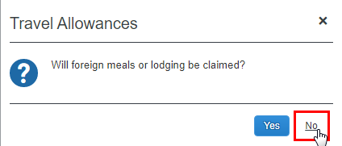

- On the left, click the Import Expenses link to view all available T&E Card transactions
- Find and select the applicable transaction for this trip by clicking in the checkbox to the left
  - Click on the blue Move button
- For airfare, enter in the details of the expense
  - In the Destination City field, select Orlando, Florida from the recently used results
  - In the Class of Service box, click the drop down and select 01. Economy
  - In the Reservation Source box, click the drop down and select 1. UC Travel Center
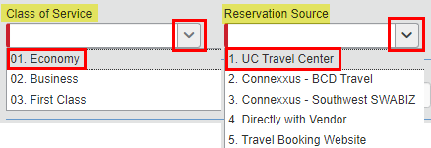

  - Next to the Comment box, there should be a Request drop down (you may need to scroll down), confirm it is populated with the $550.00 amount originally entered on the Request for this same expense type (Airfare)
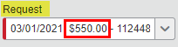

  - In the lower right corner of the page, click Allocate

  - Visually confirm the allocation entered on the Request automatically populated to the expense
  - Click Save
  - Click OK in the pop-up
  - In the lower right of the Allocation page, click Done
  - In the lower right corner of the page, click Save

- On the left click +New Expense button

- On the right, in the New Expenses section
  - Find and select the Agent Booking Fee expense type
  - In the Transaction Date field, enter 03/01/2021
  - In the Reservation Source box, click the drop down and select 1. UC Travel Center
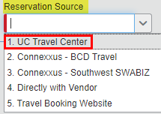

  - In the Amount field, enter $32.00
  - Next to the Comment box, there should be a Request drop down, confirm it is populated with the $32.00 amount originally entered on the Request for this same expense type (Agent Booking Fee)
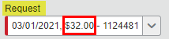

  - Click Save
- Continue to select all applicable expense for this trip. For example, you may find and select Lodging.
    - In the Transaction Date field, enter Check-out Date
    - In the Lodging Location field, select the location of the business travel
    - In the Vendor field, select your Hotel
    - In the Reservation Source box, click the drop down and select the correct option, such as 1. UC Travel Center
    - In the Amount field, enter the total cost of the hotel. For example, $1170.00
    - In the Conference/Lowest Available Rate? Field, click the drop down and select one of the options. If the hotel is through the conference, select Conference
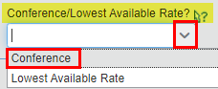
Pro Tip - hover over this icon to view helpful information

    - In the lower right corner of the page, click Itemize
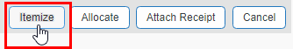

    - Leave the Check-in Date blank
    - In the Number of Nights field, enter 3
      - Doing so will auto-populate the Check-in Date
    - Under the Recurring Charges (each night) section enter:
      - Room Rate: enter the daily room rate. For example, $300
      - Room Tax: enter the daily room tax (if there are multiple taxes, such as room tax, occupational tax, then add taxes together). For example, $50
    - If there are additional charges included in the total cost, such as parking, make sure to include this when itemizing. Under the Additional Charges (each night) section:
      - Using the Expense Type drop down, find and select Parking
        - In the Amount field, enter $25
      - Using the Expense Type drop down, scroll, find, and select Phone/Internet
        - In the Amount field, enter $15
Pro Tip – Additional Charges (each night) are for additional recurring nightly charges hotels sometimes charge. Examples of these were used just above and shown in the screenshot on the next page.
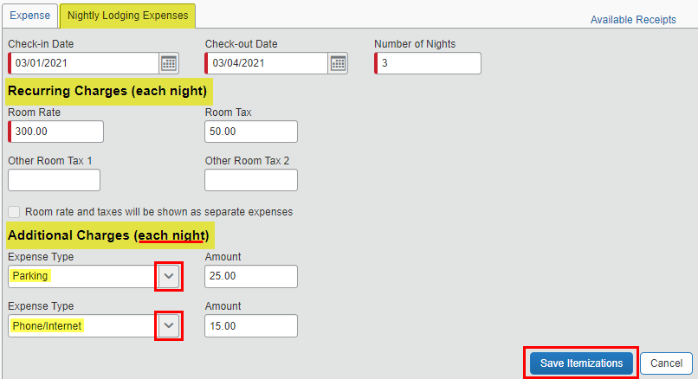
    - In the lower right corner of the page, click Save Itemizations
- To allocate expenses en masse:
  - On the left, check the top box to select all expenses
  - On the right, click 2. Allocate
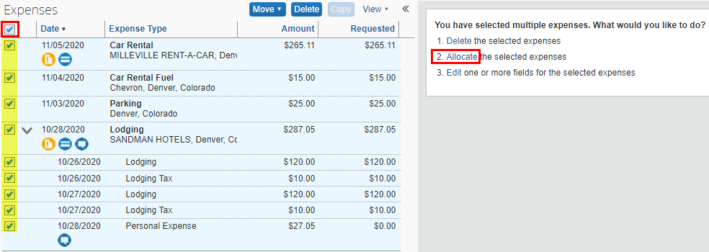

  - A new window will open (the required fields are indicated by the red asterisk *)
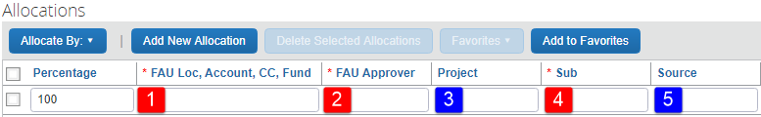

  - Click in the FAU Loc, Account, CC, Fund box and begin typing 4-441404-
    - Select the correct FAU (if you don’t know what FAU to use, please ask your fund maanger)
  - The FAU Approver drop down will automatically display, select Mark Lucas
  - Leave the Project field blank
  - In the Sub field, select 03 from the drop down
  - Leave the Source field blank
  - Click Save
  - Click OK in the pop-up
  - Click Done
- Click Submit Report
- Review the User Electronic Agreement and click Accept & Submit

  - In the Reservation Source box, click the drop down and select 1. UC Travel Center

